🔹 Step 1: Open Google Docs or MS Word
Create a new document.

🔹 Step 2: Copy this structure

📌 Title
Image Classification using Transfer Learning

🎯 Objective
To classify images (like cat/flower) using a deep learning model with transfer learning.

🧠 Algorithm Used
- CNN (Convolutional Neural Network)
- Transfer Learning (e.g., MobileNet / VGG16)

📂 Dataset
- Custom images or Kaggle dataset

⚙️ Tools Used
- Google Colab
- TensorFlow / Keras
- Python

🧾 Steps Performed
- Imported libraries
- Loaded dataset
- Preprocessed images
- Used pretrained model
- Trained model
- Tested predictions

📊 Output

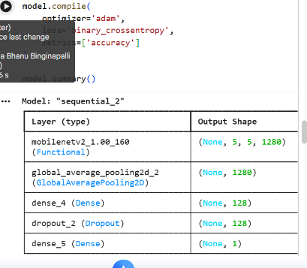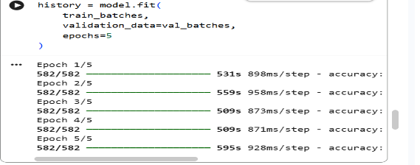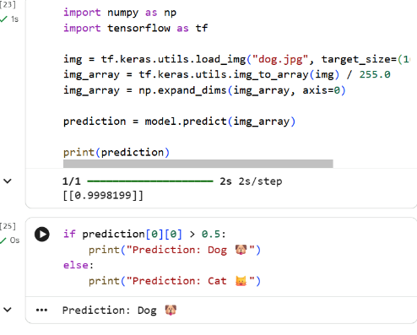

✅ Result
Model successfully classifies images with good accuracy.

🔹 Step 3: Export as PDF
- File → Download → PDF (.pdf)

